**COMPLETE THE SENTENCE WITH THE CORRECT FORM THERE IS OR THERE ARE:**

1. There are animals in the zoo.

2. There is a snake in the window.

3. There is a zebra in the grass.

4. There are lions in the zoo, too.

5. There are lions near their parents.

7. There are monkeys in the trees.

8. There is an elephant in the zoo.

9. There is water in the lake near the elephants.

10. There are birds in the zoo.

1. Answer the questions
2. How many rooms are there in your house? There are 4 rooms in my house.
3. How many kitchens are there in your house? There is a kitchen in my house.
4. How many bathrooms are there in your house? There are 3 bathrooms in my house.
5. Is there a swimming pool in your house? There isn`t a swimming pool in my house.
6. Is there a garden in your house? There isn’t a garden in my house.
7. Are there dogs in your house? Yes, there is a dog in my house.
8. Use this- that- these- those

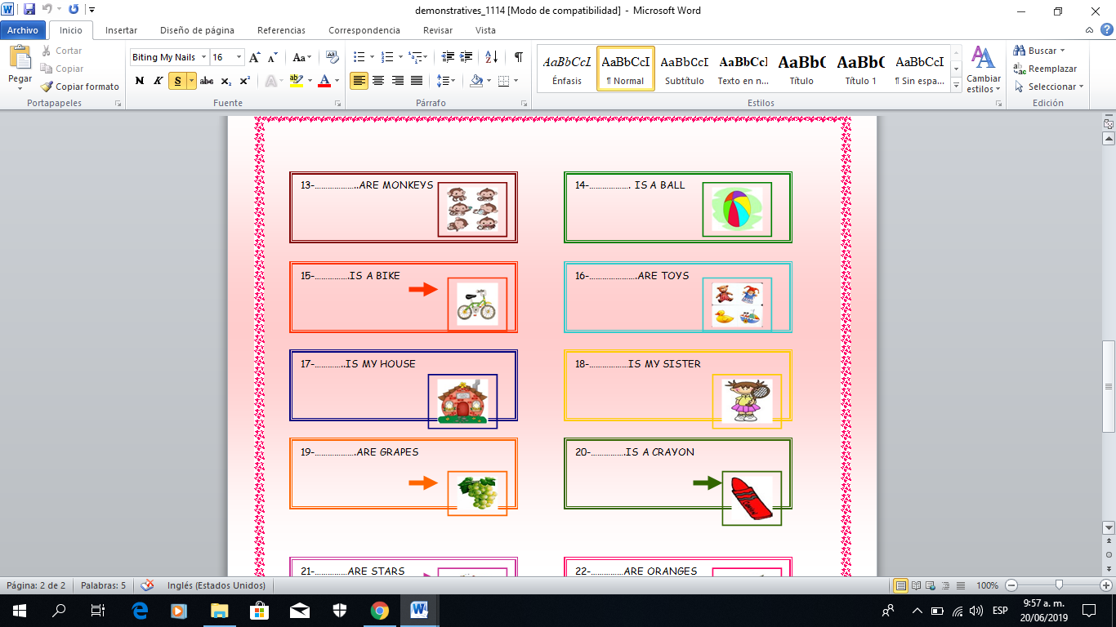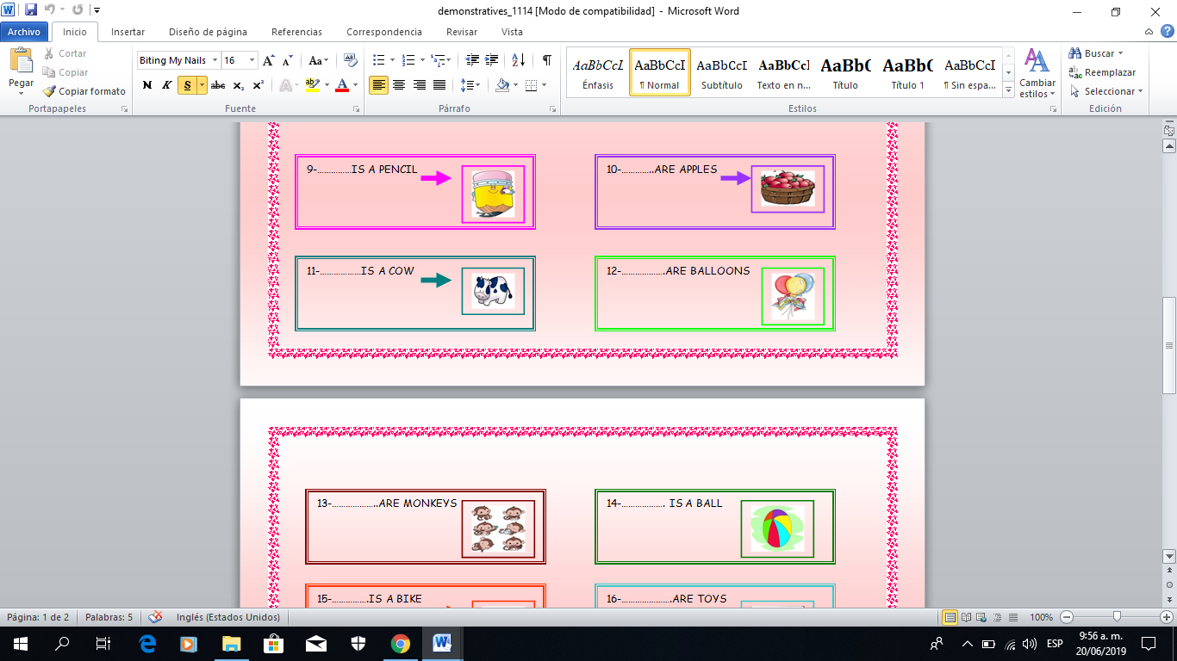

THOSE

THIS

THIS

THESE

THIS

THESE

THIS

THESE

1. Choose the right option

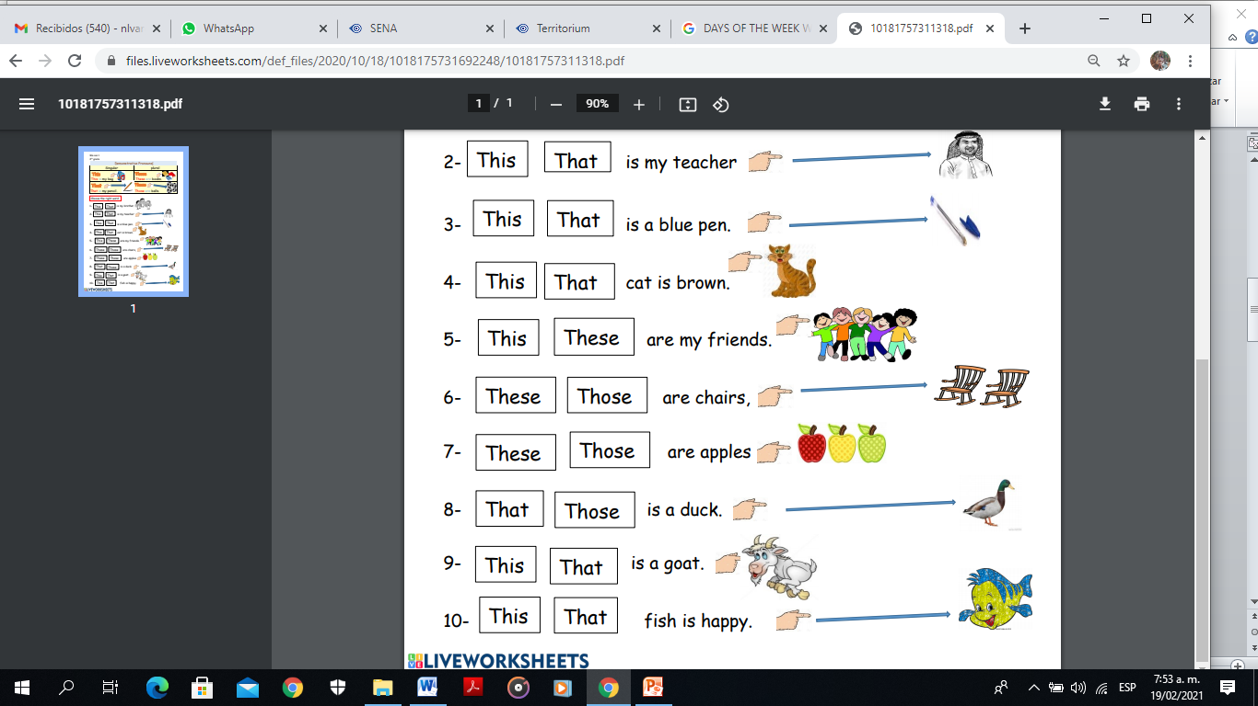

1. Answer about their birthdays. Example

* When is Tina’s birthday?

Her birthday is on February 3rd

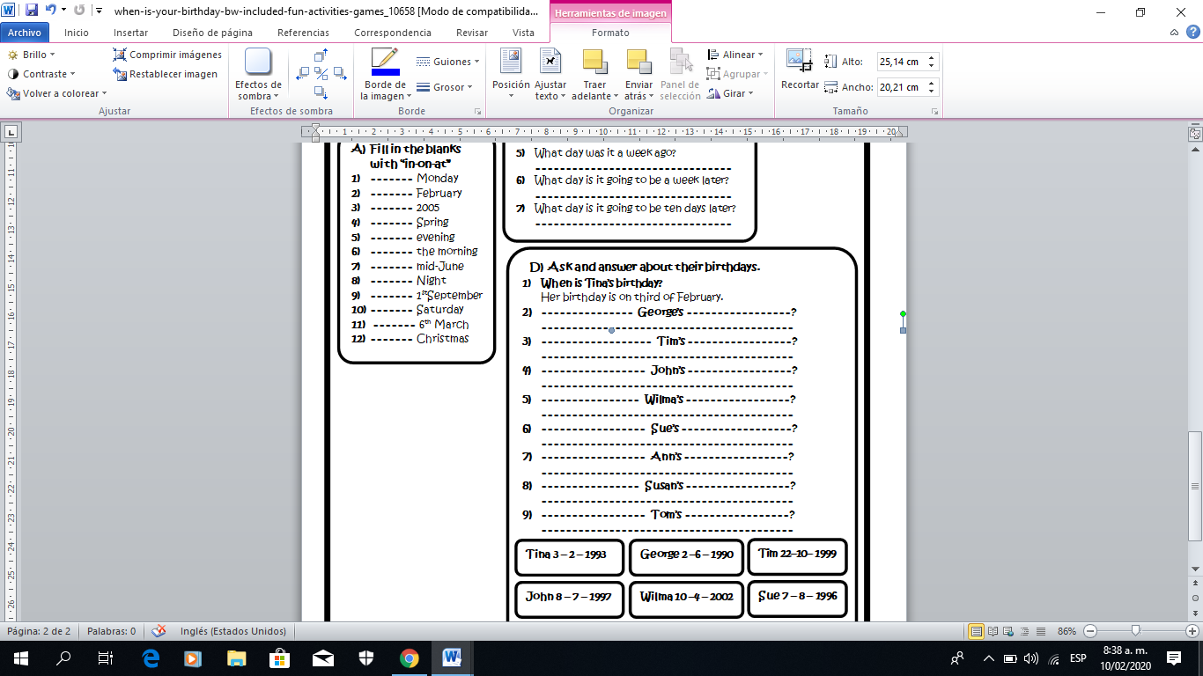

1. When is George´s birthday?

His birthday is on June 2nd

1. When is Tim´s birthday?

His birthday is on October 22nd

1. When is John´s birthday?

His birthday is on July 8th

1. When is Wilma´s birthday?

Her birthday is on April 10th

1. When is Sue´s birthday?

Her birthday is on August 7th

1. When is Tina´s birthday?

Her birthday is on February 3rd

1. Complete with the correct MONTH in English
2. Independence day is in July .
3. Halloween day is in October .
4. Christmas day is in December .
5. My birthday is in March .
6. Boyaca Battle is in August .
7. Work day is in May .
8. Imagine today is WEDNESDAY so complete the sequence

* Tomorrow will be Thursday .
* Yesterday was Tuesday .
* After tomorrow will be Friday .
* Before yesterday was Monday .

1. Answer the question

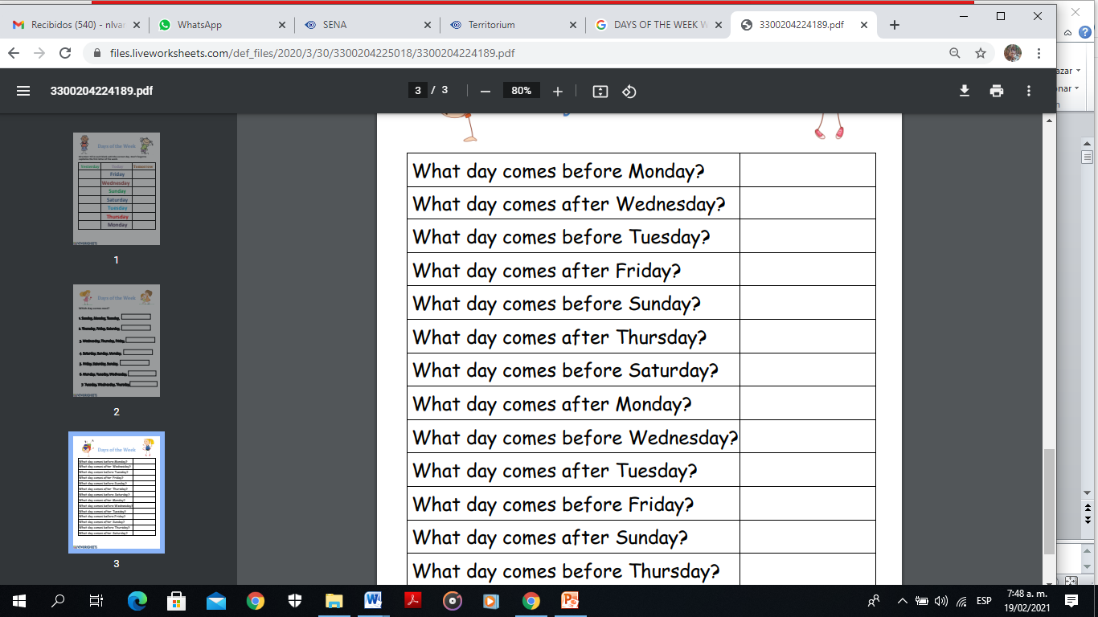

Sunday

Thursday

Monday

Saturday

Friday

Tuesday

Wednesday

Tuesday

Friday

Saturday